Testing Document

|  |  |  |  |  |
| --- | --- | --- | --- | --- |
| Test No | Method | App/Tool | Expected Output | Result |
| 1 | Connecting on unicast/multicast |  | Will connect based on available mode | Success |
| 2 | Press connect on Settings |  | Nothing should happen | Success |
| 3 | Change settings and pressing save/discard |  | Changes will either be reverted or changed based on the button changed | Success |
| 4 | On multicast, when connected |  | Music will start playing and information of current song will be displayed | Success |
| 5 | On unicast, when connected, press the play button after selecting a song |  | The song will start playing | Success |
| 6 | On unicast, when connected, press the download button after selecting a song. |  | The song will start downloading | Success |
| 7 | On unicast, download a song when playing a song and vice versa |  | Will be able to both download and play song, even on the same song | Success |
| 8 | On unicast, when playing a song, select and play a song |  | Cannot play a song while there is currently a song playing | Success |
| 9 | On unicast, when downloading a song, select and download a song |  | Cannot download a song while there is currently a song playing | Success |
| 10 | Download the song according to Filepath |  | Download on the correct location, default is on the folder the executable is | Success |
| 11 | Microphone disconnected when microphone off |  | Microphone is defaulted back to on when disconnecting | Success |
| 12 | Microphone button pressed when disconnected |  | Button won’t change | Success |

Client:

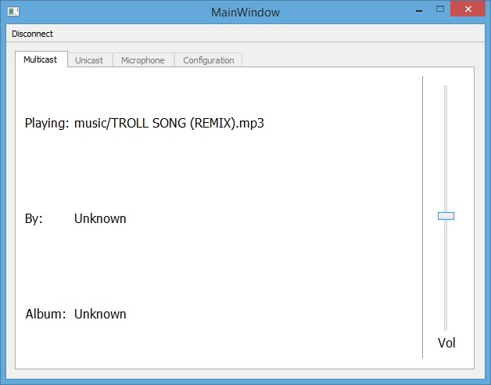

Server:

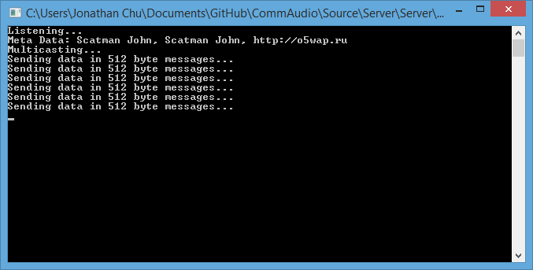

Test 1, 4: The connecting button will check for current mode and set it based on the server, the music will be started as soon as possible and the information will be set if the data is available.

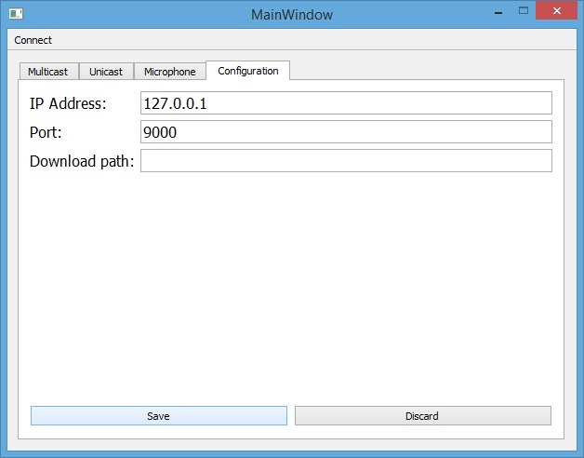

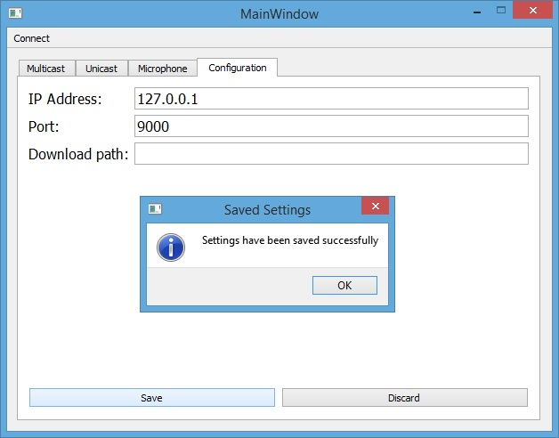

Test 2 ,3: Pressing on connect will not do anything, when pressing the save button there will be a pop up window to let the user know that the settings were saved; however, if the button discard is clicked the settings will revert to the last saved settings or the default if there were no saved settings.

Client:

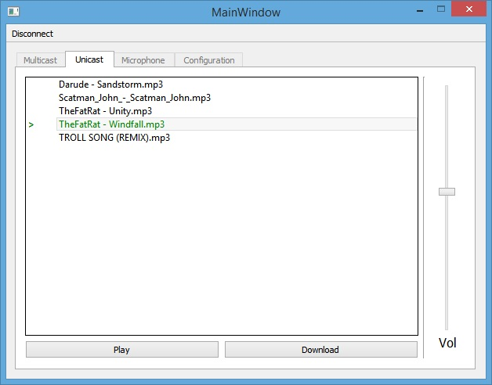

Server:

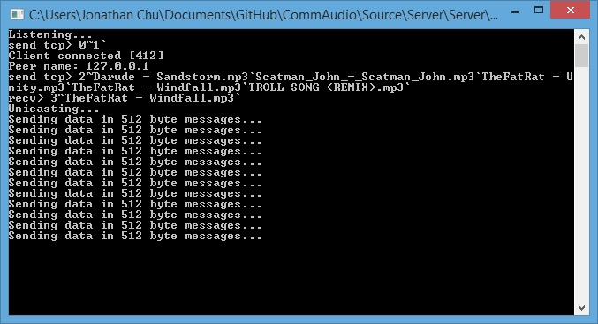

Test 5: Once the song is selected and the button Play is clicked, the song will start playing as long as the song being played will be identified by changing the font to green and adding an ‘>’ arrow next to the song.

Client:

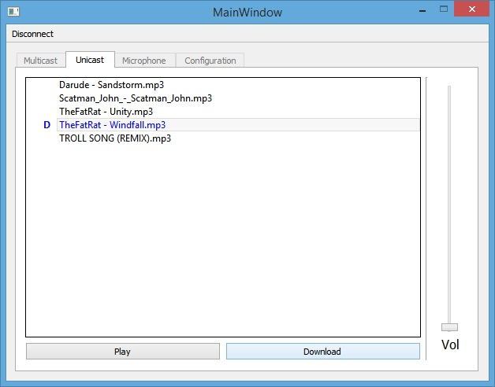

Server:

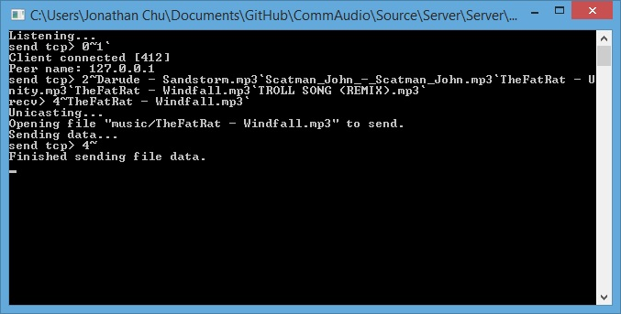

Test 6: When pressing the download, the currently selected song will start downloading and it will be identified by a blue font and a ‘D’ next to the song.

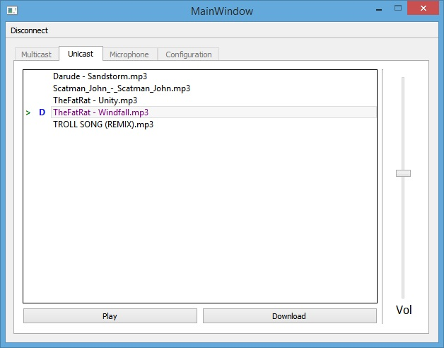

Test 7, 8, 9: Having a song being downloaded as well as being played won’t cause any problems. The way to identify a song that is both being downloaded and played is by having both the icons ‘>’ and ‘D’ as well as changing the font color to purple. . The downloading and playing of the song can be concurrent as seen here.

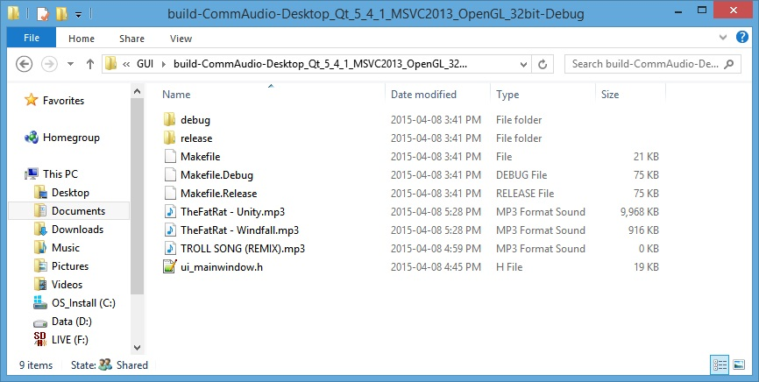

Test 10: The saved files will be put on the default folder where the build folder is for the client. The default folder is blank and in order to go to the desired folder, one has to specify it on the configurations.

Disconnected:

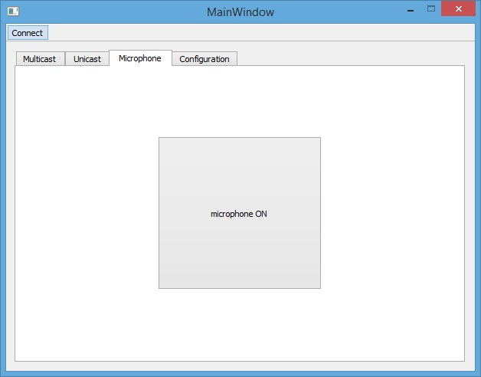

Connected:

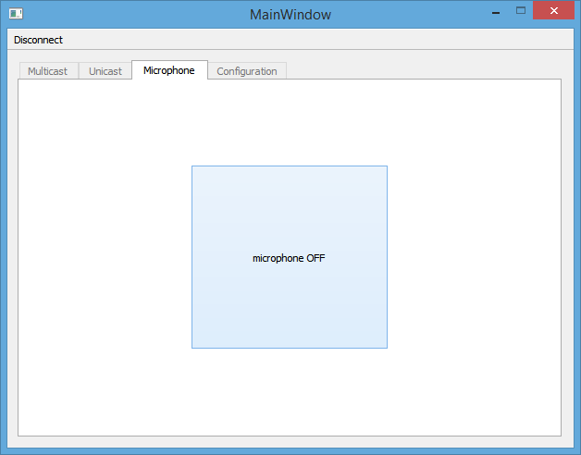

Test 11, 12: The button will only be able to be turned off when it is connected, and when it disconnects while the button is off, it will be reset to on.